# T 1.3 – Setup PHPStorm

## PHP instellen

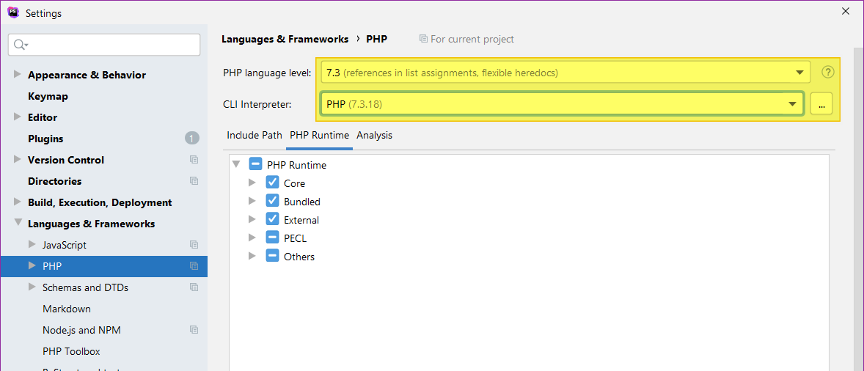

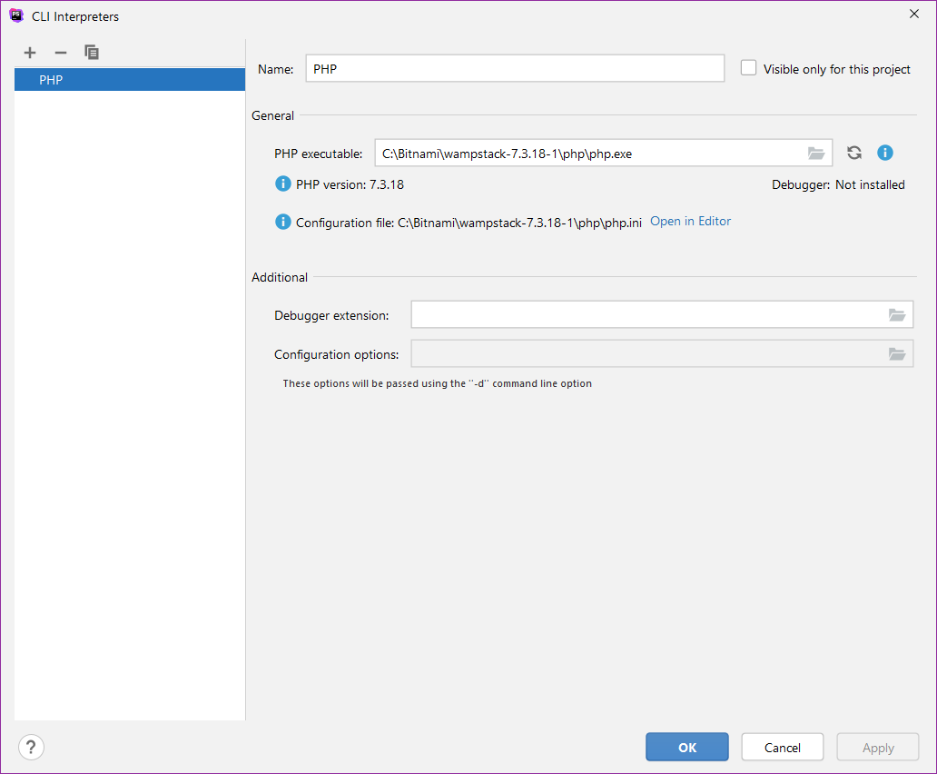

## Ctrl-scroll inschakelen

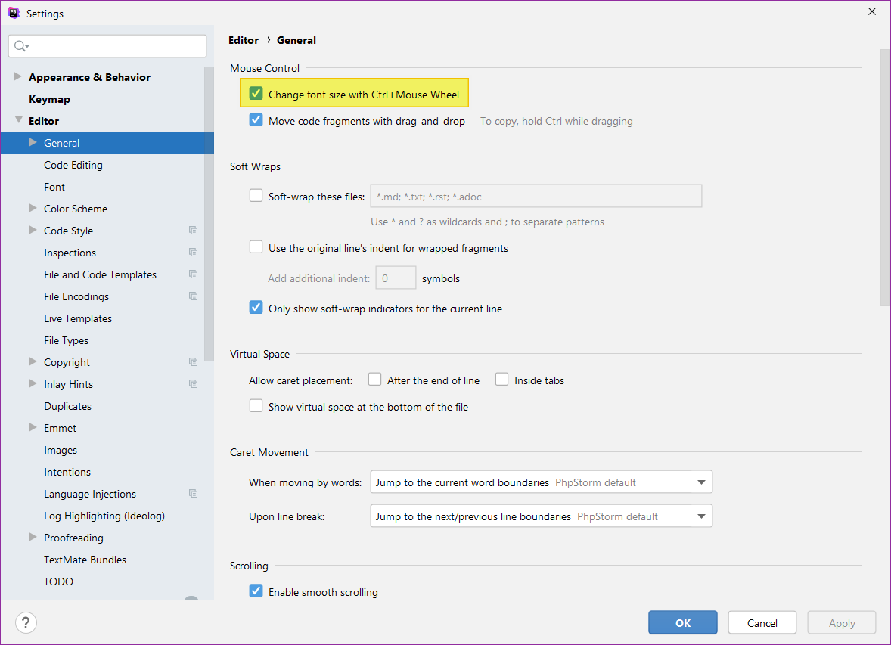

## Key mappings toevoegen (Ctrl-E => Delete Line)

